**Bentley 3.5 litre Sedanca Coupe, 1934**

With its long bonnet and sweeping lines, this car has extremely glamorous looks. Inside are features-cushijns, mirrors and leather seats – it associate with plush home interiors

The 1934 Bentley 3.5 Litre Sedanca Coupe is a classic luxury car renowned for its elegant design and performance. It features a 3.5-liter straight-six engine, capable of delivering around 110 horsepower. This model was part of Bentley's famous "3.5 Litre" series, which was produced in the early 1930s and is celebrated for its combination of style, comfort, and driving experience.

The Sedanca Coupe variant specifically is characterized by its distinctive two-door design with a fixed roof and a retractable rear roof section, offering an open-air driving experience while maintaining a sleek silhouette. The craftsmanship and attention to detail in these vehicles were exceptional, with high-quality materials and bespoke options for wealthy clients.

Many of these cars are now sought after by collectors and classic car enthusiasts, often fetching high prices at auctions. The 3.5 Litre Sedanca Coupe remains a symbol of luxury and automotive history from the pre-war era.

**Flame Thrilled!**

This fire engine was used in Ireland by Galway fire brigade. Its open body meant firefighters could quicky jump on and off when called out to a blaze, saving vital seconds.

This particular model might have been used in cities to extinguish fires on upper floors of buildings, thanks to its ladder and powerful pump system. Such vehicles contributed significantly to improving the work of fire brigades in the first half of the 20th century, when quick access to water and high-rise equipment became essential for urban fire departments.

**Vintage motorhome or travel trailer**

This photo shows a vintage motorhome or travel trailer, likely from the mid-20th century. The sign on the door reads **"L'Autocaravane**" — the French term for a motorhome or camper. These types of vehicles were popular among travellers seeking comfort and freedom of movement. They often featured a small living room, kitchen, and sleeping areas, allowing owners to travel in comfort.

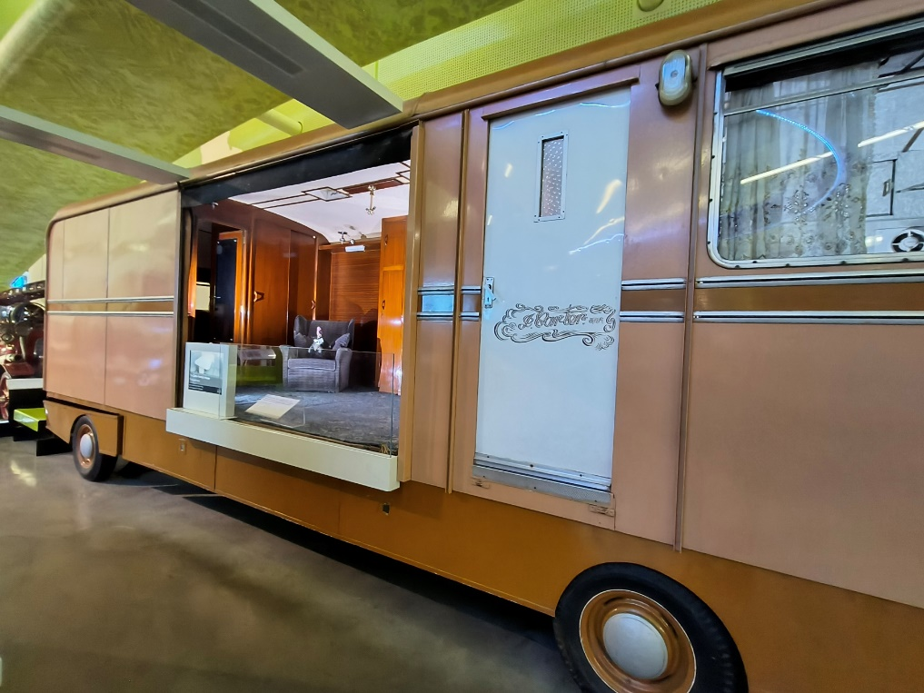These motorhomes played an important role in developing camping and road-trip culture, especially in Europe, where people looked for new ways to explore nature and city attractions.

